**2. Microservices with API gateway**

**Creating Microservices for the account and loan**

In these hands-on exercises, we will create two microservices for a bank. One microservice for handling accounts and one for handling loans.

**Steps:**

**Account Microservice Implementation**

1. Generate a Spring Boot Project

* **Group:** com.cognizant
* **Artifact:** account
* **Dependencies:**
* Developer Tools → **Spring Boot DevTools**
* Web → **Spring Web**

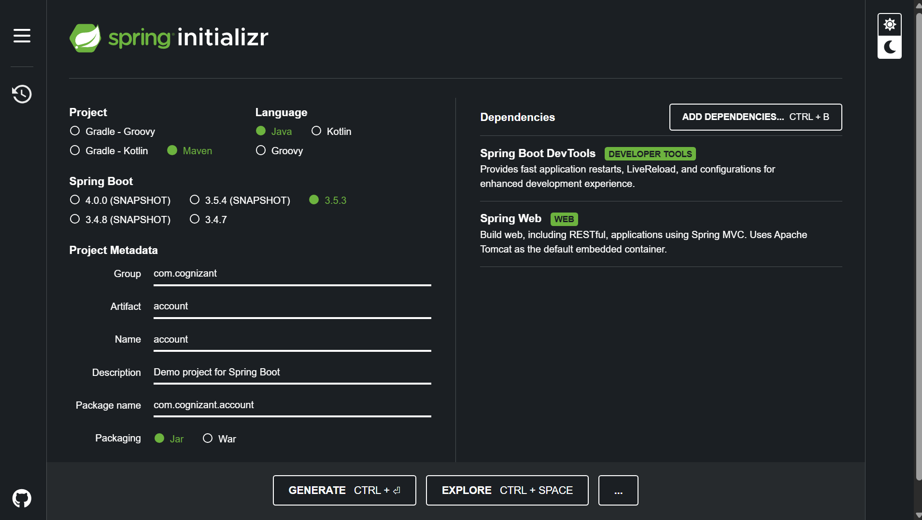

* **Technology Used:** Spring Boot, Maven
* **Endpoint:** GET /accounts/{number}
* **URL for Testing:**  
  <http://localhost:8080/accounts/00987987973432>

2. Build Project with Maven

* Extract the downloaded **account.zip** file.
* Open **Command Prompt (cmd)**

**Run:** mvn clean package

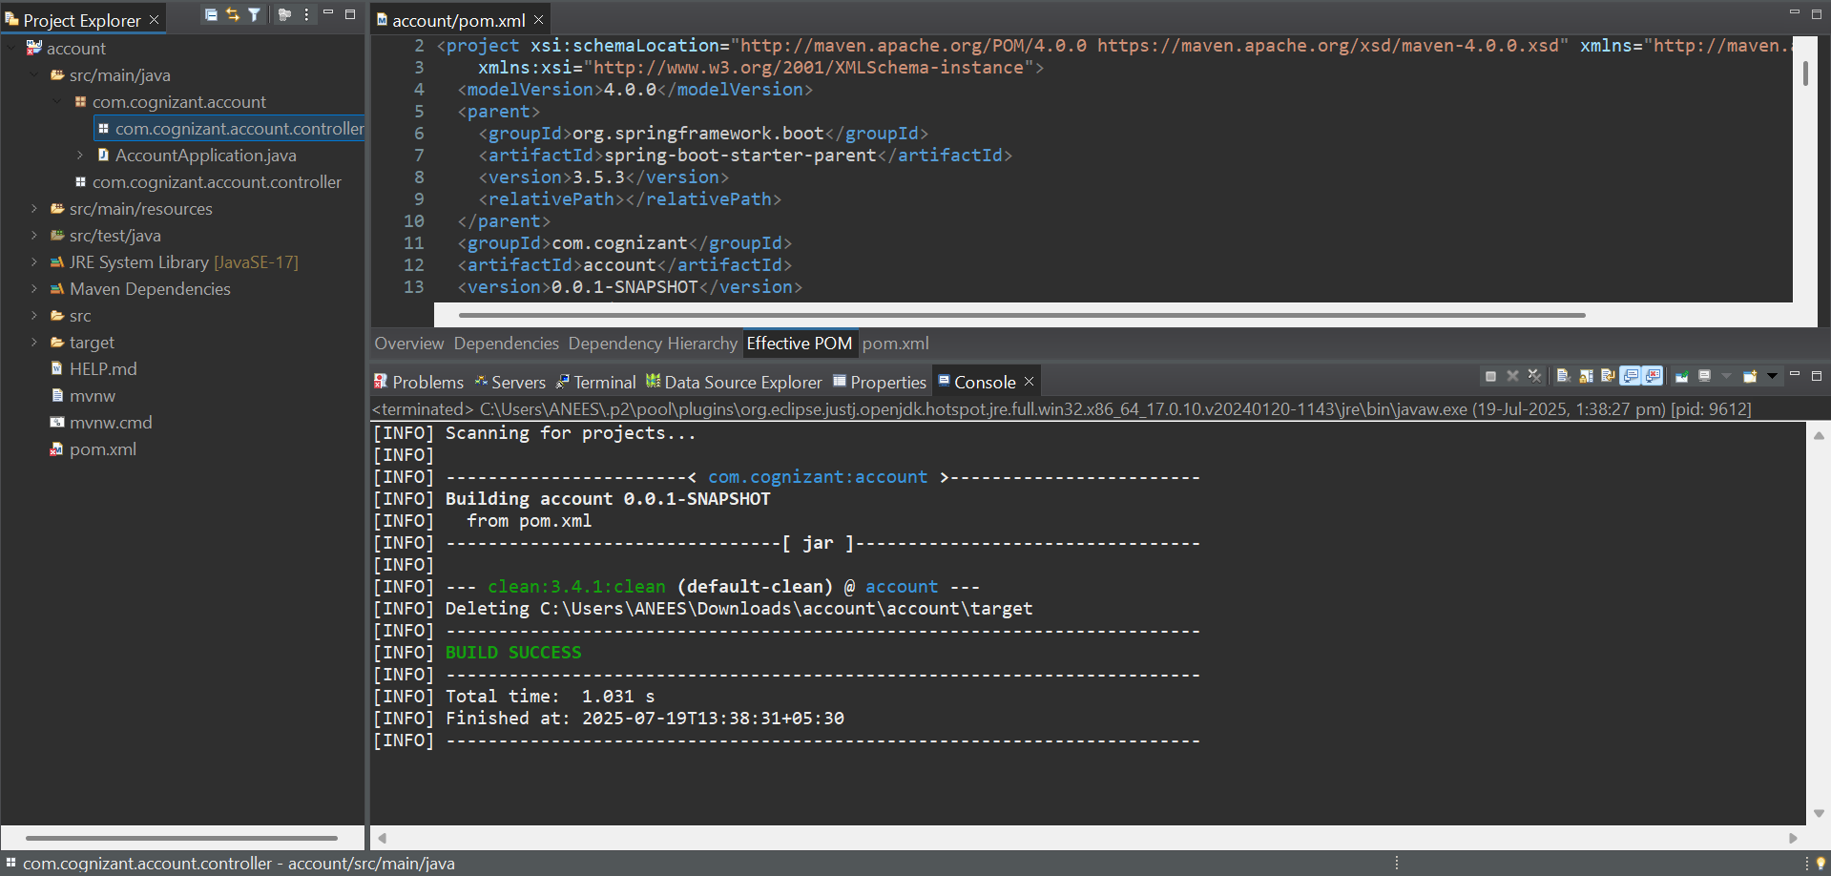

AccountController.java:

package com.cognizant.account.controller;

import org.springframework.web.bind.annotation.*;

@RestController

@RequestMapping("/accounts")

public class AccountController {

@GetMapping("/{number}")

public Account getAccount(@PathVariable String number) {

return new Account(number, "savings", 234343);

}

static class Account {

private String number;

private String type;

private double balance;

public Account(String number, String type, double balance) {

this.number = number;

this.type = type;

this.balance = balance;

}

public String getNumber() { return number; }

public String getType() { return type; }

public double getBalance() { return balance; }

}

}

**AccountApplication.java**

package com.cognizant.account;

import org.springframework.boot.SpringApplication;

import org.springframework.boot.autoconfigure.SpringBootApplication;

*@SpringBootApplication*

public class AccountApplication {

public static void main(String[] args) {

SpringApplication.*run*(AccountApplication.class, args);

}

}

**Output:**

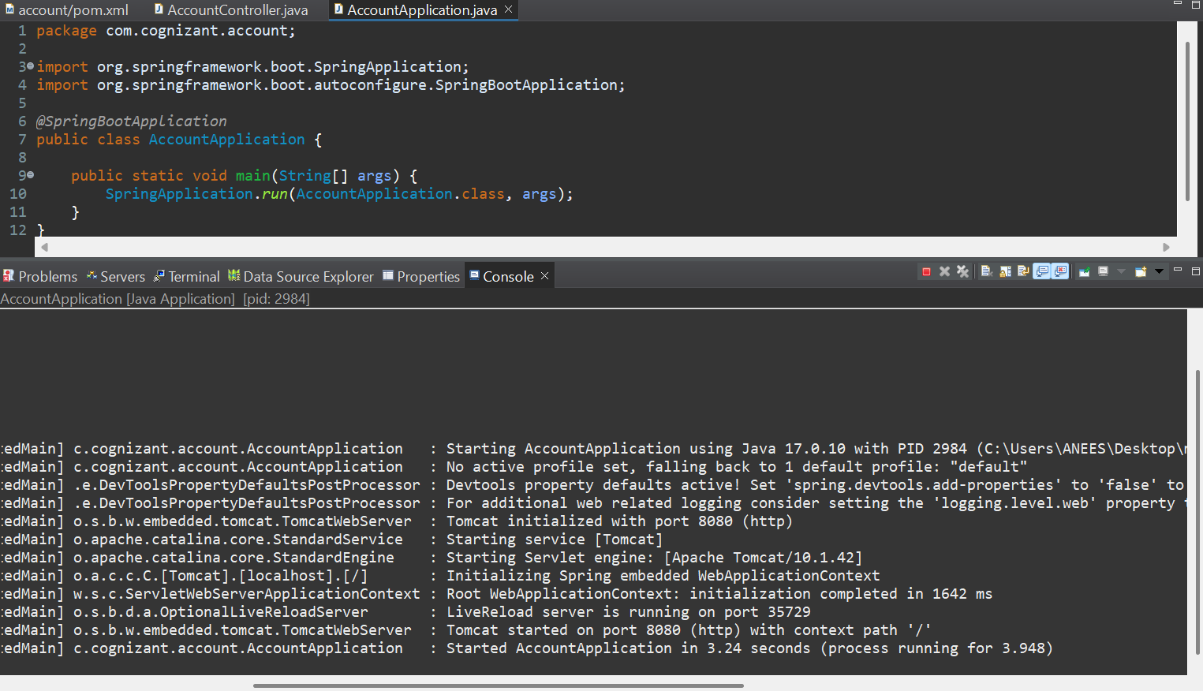

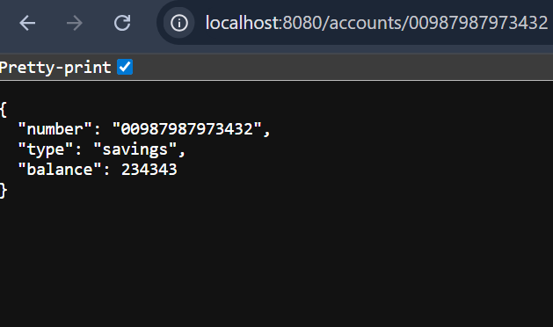

**Loan Microservice Implementation**

1.Generate a Spring Boot Project

* **Group:** com.cognizant
* **Artifact:** loan
* **Dependencies:**
* Developer Tools → **Spring Boot DevTools**
* Web → **Spring Web**

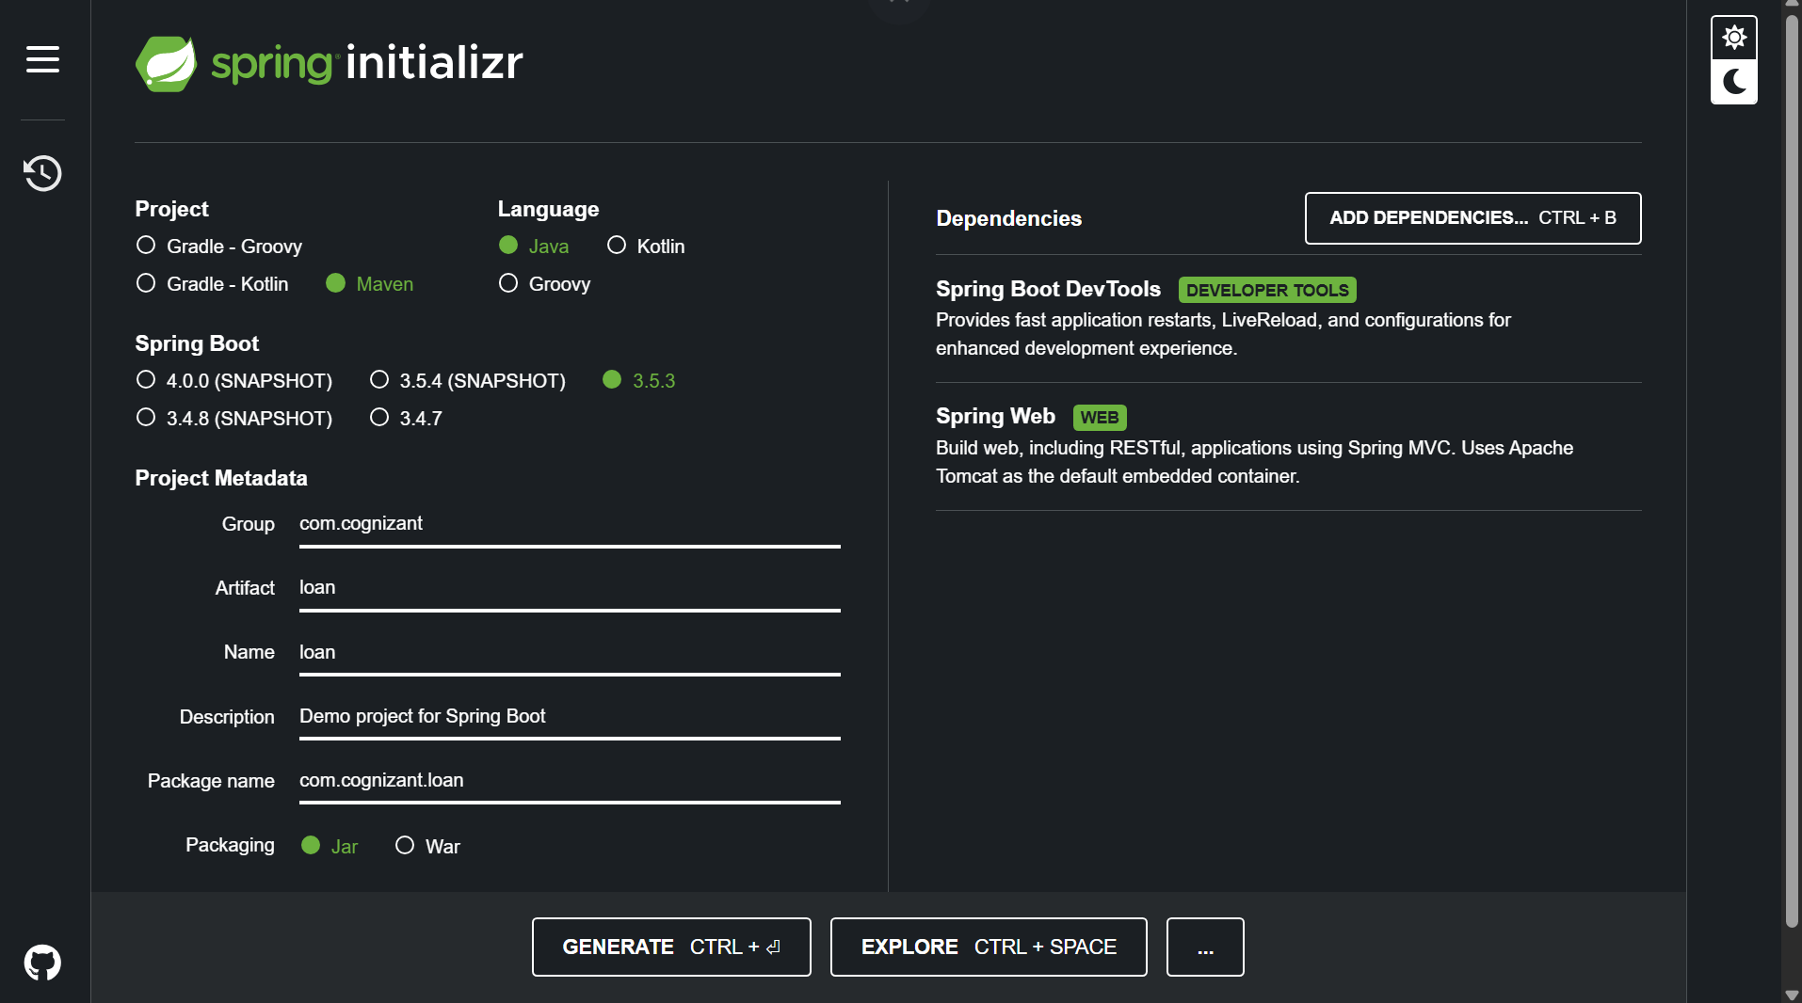

* **Technology Used:** Spring Boot, Maven
* **Endpoint:** GET /loans/{number}
* **Port Configured:** 8081
* **URL for Testing:** http://localhost:8081/loans/H00987987972342

**LoanController.java**

package com.cognizant.loan.controller;

import org.springframework.web.bind.annotation.*;

@RestController

@RequestMapping("/loans")

public class LoanController {

@GetMapping("/{number}")

public Loan getLoan(@PathVariable String number) {

return new Loan(number, "car", 400000, 3258, 18);

}

static class Loan {

private String number;

private String type;

private double loan;

private double emi;

private int tenure;

public Loan(String number, String type, double loan, double emi, int tenure) {

this.number = number;

this.type = type;

this.loan = loan;

this.emi = emi;

this.tenure = tenure;

}

public String getNumber() { return number; }

public String getType() { return type; }

public double getLoan() { return loan; }

public double getEmi() { return emi; }

public int getTenure() { return tenure; }

}

}

**LoanApplication.java**

package com.cognizant.loan;

import org.springframework.boot.SpringApplication;

import org.springframework.boot.autoconfigure.SpringBootApplication;

@SpringBootApplication

public class LoanApplication {

public static void main(String[] args) {

SpringApplication.run(LoanApplication.class, args);

}

}

**Output:**

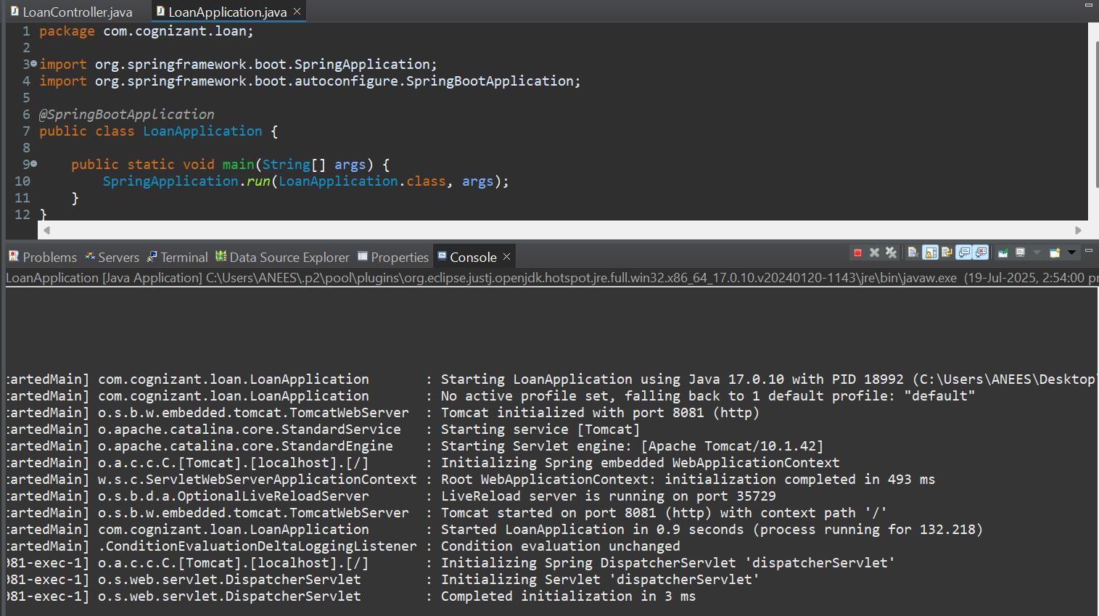

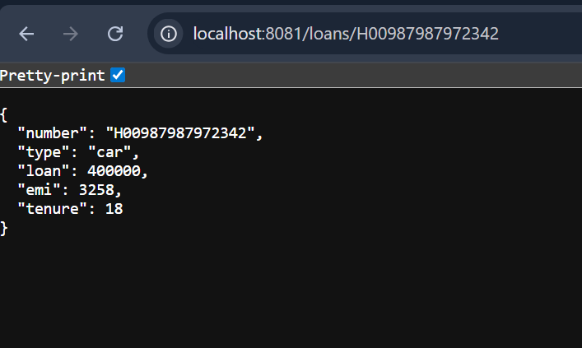

**Final Output:**

